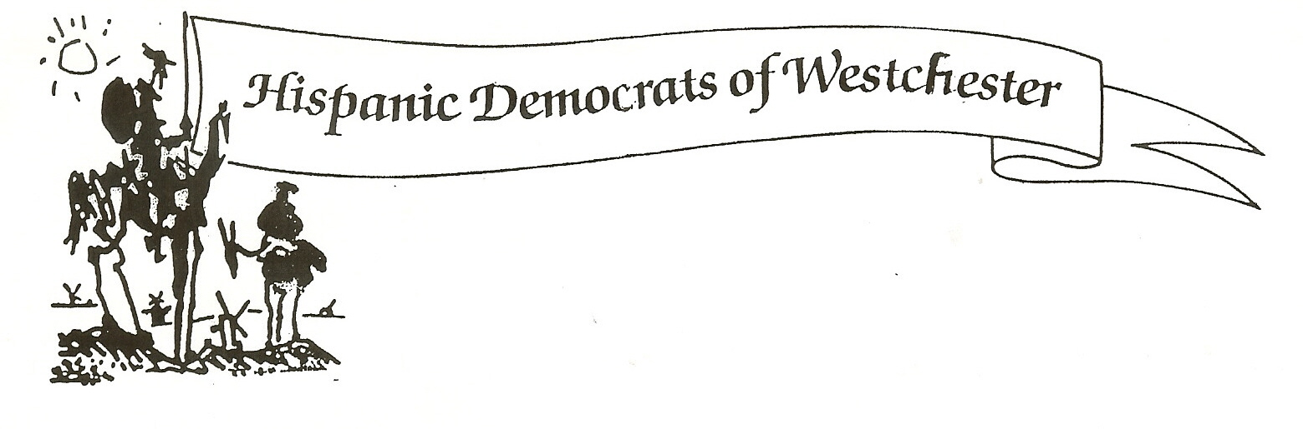
Robin A. Bikkal &

Ximena Francella

Co-Chairs

Martha Lopez-Hanratty

1st Vice Chair

George W. Echevarria

2nd Vice Chair

Grisselle Feliciano

Secretary

Esteban Michaca

Treasurer

Executive Committee

Victor Avendano

Jose Chevere

Isabel Figueroa

Milagros Lecuona

Luis Mariño

Benito Martinez

Maria Portilla

Carlos Ramirez

Evelyn E. Santiago

July 24, 2017

Re: Milagros Lecuona for White Plains Mayor

Dear Ms. Lecuona,

On behalf of the executive committee of the Hispanic Democrats of Westchester, I am delighted to inform you that you have been endorsed for the position of White Plains mayor.

We believe that as a councilwoman for the City of White Plains you have always exhibited the highest level of integrity, knowledge and dedication to the citizenry of White Plains.

We believe you are the best candidate to represent the interests of all of the residents of this great city. We cite as examples your dedication to the preservation of the environment, your commitment to the small businesses throughout the city, and your insistence on having a more open government.

Your professional background as an architect as well as your personal background as an immigrant to this great country has given you unique tools that have benefited White Plains as a councilwoman, and which will be magnified as mayor of White Plains.

We look forward to working with you in the future and are fully confident that you are the best candidate not only for the Hispanic community but for the entire White Plains community as well.

Sincerely,

Robin A Bikkal Ximena Francella

